

Project Design Phase-II Technology Stack (Architecture & Stack)

|  |  |
| --- | --- |
| Date | 28 October 2022 |
| Team ID | PNT2022TMID40963 |
| Project Name | IOT Based Smart Crop Protection System for Agriculture |
| Maximum Marks | 4 Marks |

Technical Architecture:

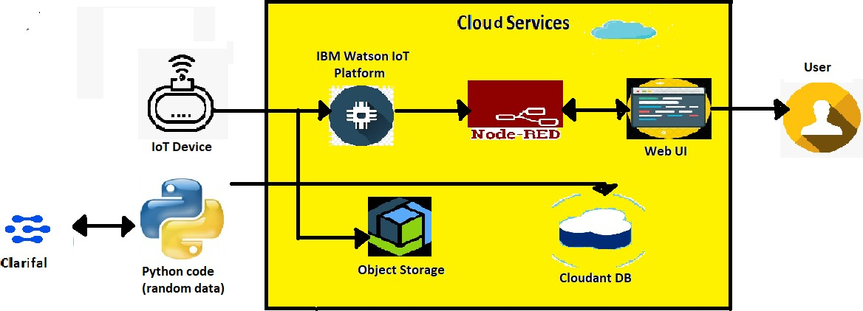

Table-1 : Components & Technologies:

|  |  |  |  |
| --- | --- | --- | --- |
| **S.No** | **Component** | **Description** | **Technology** |
| 1. | User Interface | User can get notification and turn on Motors and sprinklers | Web UI |
| 2. | Application Logic-1 | Get data from Raspberry pi(sensor) and process using python | Java / Python |
| 3. | Application Logic-2 | Store data collected in the cloud | IBM Watson STT service |
| 4. | Database | CSV data from Raspberry pi | IBM Watson cloud |
| 5. | Cloud Database | Database Service on Cloud | IBM DB2, IBM Cloud etc. |
| 6. | File Storage | File storage requirements | IBM Block Storage or Other Storage  Service or Local Filesystem |
| 7. | External API-1 | Get Humidity, Weather and Temperature | IBM Weather API, etc. |
| 8. | Machine Learning Model | Open CV | Animal and Bird Recognition Model. |
| 9. | Infrastructure (Server / Cloud) | Application Deployment on Local System / Cloud | IBM Watson cloud |

Table-2: Application Characteristics:

|  |  |  |  |
| --- | --- | --- | --- |
| **S.No** | **Characteristics** | **Description** | **Technology** |
| 1. | Open-Source Frameworks | Create functionality by writing together flows of data  between nodes using a browser. | Node-Red |
| 2. | Security Implementations | Offers security and reliability. | SHA-256 |
| 3. | Scalable Architecture | Massive network that supports IoT devices and  applications. | Cloud App |
| 4. | Availability | Availability is more. | IBM Cloud |
| 5. | Performance | Performance is high such that number of requests per  sec is high, use of Cache and use of CDN’s in high. | Node-Red, IBM cloud |